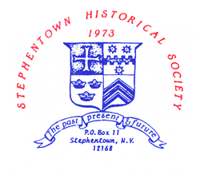
PROGRAMS
STEPHENTOWN HISTORICAL SOCIETY
NOVEMBER 2022 TO APRIL 2023
ALL PROGRAMS ARE HELD ON SUNDAY AT 2 PM AT THE HERITAGE CENTER

Nov. 6 - Women in the Military – Diana Clark
Dec. 4 - Potluck Holiday Luncheon featuring Songs of
Christmas Past and Elizabeth Goodermote
Jan 8 - Unknown D-Day – Eric Durr
Feb 5 - Freedom Riders – Gerry Robinson
March 5 - “What Shall We Do With the Dead, Sir?” –
Mortuary Practices During the American Civil War
Robert Shuey
April 2 - The Berlin Explosion – 60th Anniversary, Sharon
Klein

Not able to attend? Watch on YouTube – search “Stephentown Historical”

