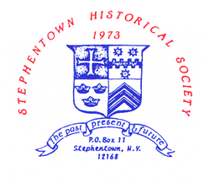
PROGRAMS -- STEPHENTOWN HISTORICAL SOCIETY
JANUARY TO AUGUST 2023
ALL PROGRAMS ARE HELD ON SUNDAY AT 2 PM AT THE HERITAGE CENTER
Jan 8 - Unknown D-Day – Eric Durr
Feb 5 - Freedom Riders – Gerry Robinson
March 5 - “What Shall We Do with the Dead, Sir?” –
Mortuary Practices During the American Civil War
Robert Shuey
April 2 - The Berlin Explosion – 60th Anniversary
Sharon Klein
May 7 - For the Cause – Women of the Civil War
Phyllis Chapman
June 4 - Antique Clocks – Paul Borst
July 9 - Annual Picnic
August 6 - From the Record – Wally Stock

Not able to attend? Watch on YouTube – search “Stephentown Historical”

