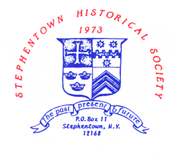
PROGRAMS -- STEPHENTOWN HISTORICAL SOCIETY
JUNE TO SEPTEMBER 2023
ALL PROGRAMS ARE HELD ON SUNDAY AT 2 PM AT THE HERITAGE CENTER

June 4 - Antique Clocks – Paul Borst
July 9 - Annual Picnic BBQ
(NOTE: Picnic to be held in conjunction with SHS’s 50th Anniversary Celebration Weekend – July 8th & 9th)
August 6 - From the Record – Wally Stock
Sept 10 - Spring Swamp Life – Trix Nierembergen

Not able to attend? Watch on YouTube – search @stephentownhistorical233

